**INDEX**

|  |  |
| --- | --- |
| **S.NO** | **Topic** |
| **1** | **Creation of Dimensions and Fact tables.** |
| **2** | **Create Data Source using SSAS (SQL Server Analysis Services.)** |
| **3** | **Create Data Source View using SSAS (SQL Server Analysis Services.)** |
| **4** | **Create cube using SSAS (SQL Server Analysis Services.) and process the cube.** |
| **5** | **View cube data in multidimensional Format. (Excel Pivot Chart.)** |
| **6** | **Working with measures in the cube.** |
| **7** | **Creating an Excel Pivot Table and Pivot Chart by using the OLAP cube data.** |
| **8** | **Firing Queries on Tables.** |

**Practical No 1**

**Aim: Creation of Dimensions and Fact tables.**

**Solution:**

**Open Application -> Microsoft SQL Server 2008 R2 -> SQL Server Management Studio**

1. **Select Connect Tab -> Database Engine -> Select Server Name(local)**
2. **Right Click the Database -> New Database**
3. **Types “StudentReport” as the database name, click on OK to close the dialog box and to create the database.**

**Create a Database Diagrams**

**Expand the “StudentReport” database folder.**

1. **Click on Database Diagrams to expand it**

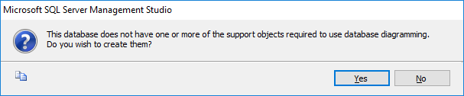

**On click of it, above Dialog box appears, click on Yes to close it.**

1. **Right Click on Database Diagrams -> New Database Diagrams**
2. **Create fact and Dimension Tables. (Right click on surface, choose New Table to add tables on Database Diagrams.)**

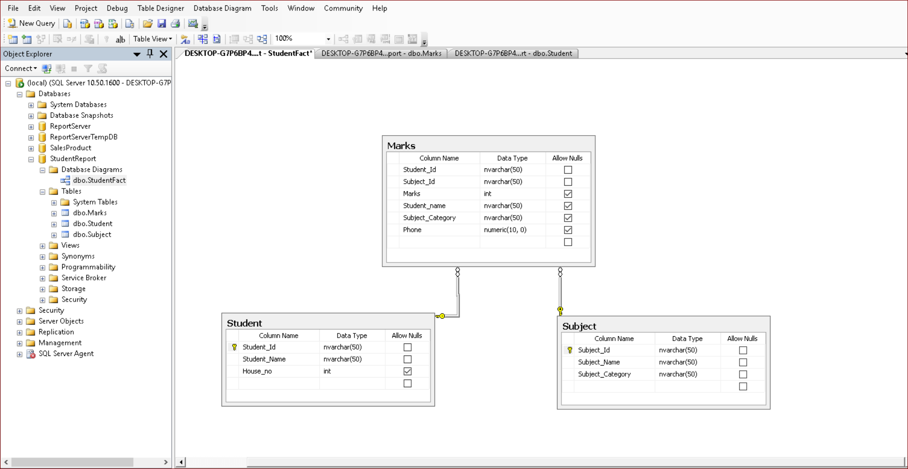

1. **Establish relationship between fact and dimension tables.**
2. **Save Database Diagrams with name as “StudentFact”. (After saving Database Diagrams fact and dimension tables are automatically placed in Table tab.)**

**Practical No 2**

**Aim: Create Data Source using SSAS (SQL Server Analysis Services.)**

**Solution:**

**Open Application -> Microsoft SQL Server 2008 R2 -> SQL Server Business Intelligence Development Studio**

1. **Select File -> New Project -> Choose Analysis Service Project -> Name it as “Student2021” and click on OK.**
2. **Right Click on Data Sources -> New Data Source**

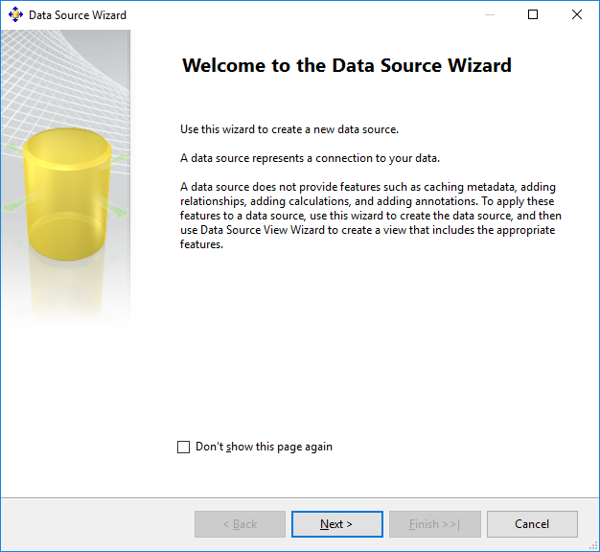

**Click on Next.**

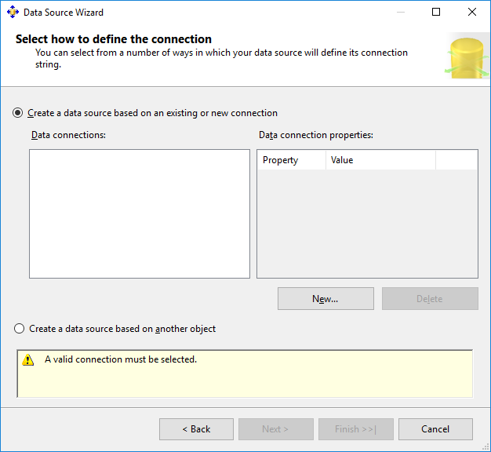

**Click on New.**

1. **Choose Provider as “Microsoft OLEDB Provider for SQL Server”, Server Name as “.”, Select database name as “StudentReport”. (Created in SQL Server Management studio).**

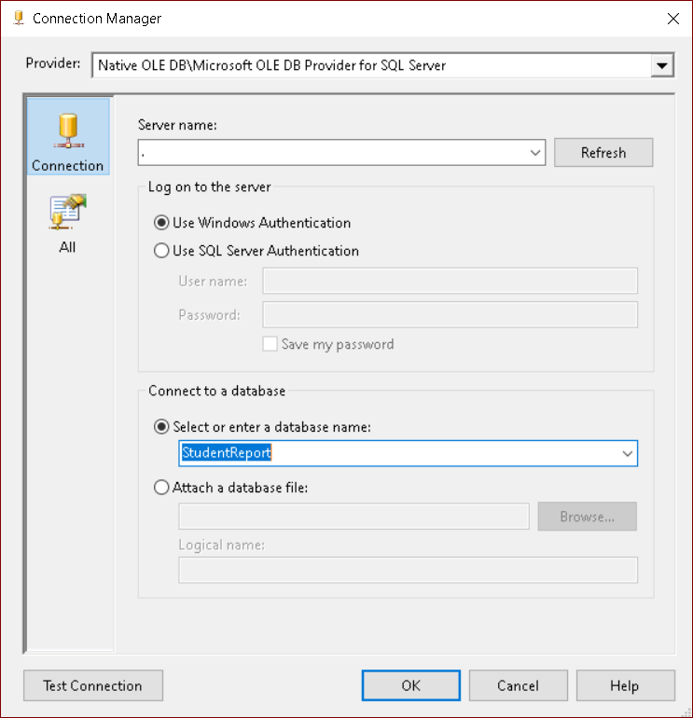

1. **Click on Test Connection.**

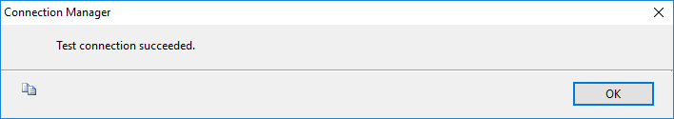

**Click on OK.**

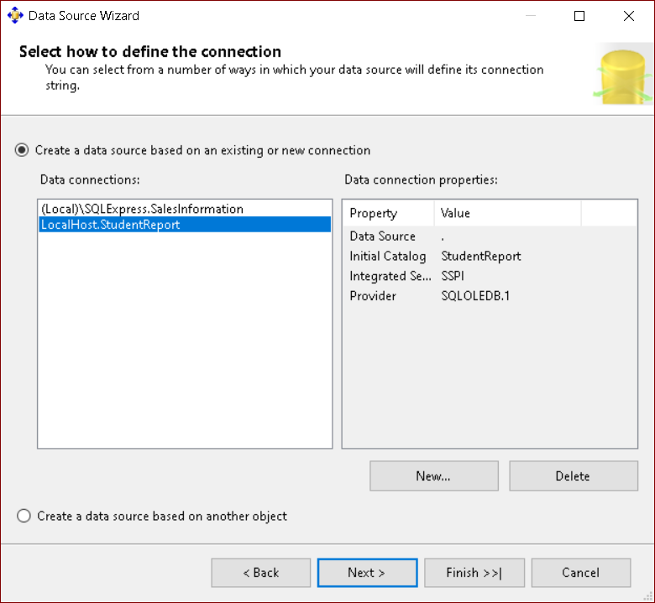

**Click on Next.**

1. **Choose “Inherit” option.**

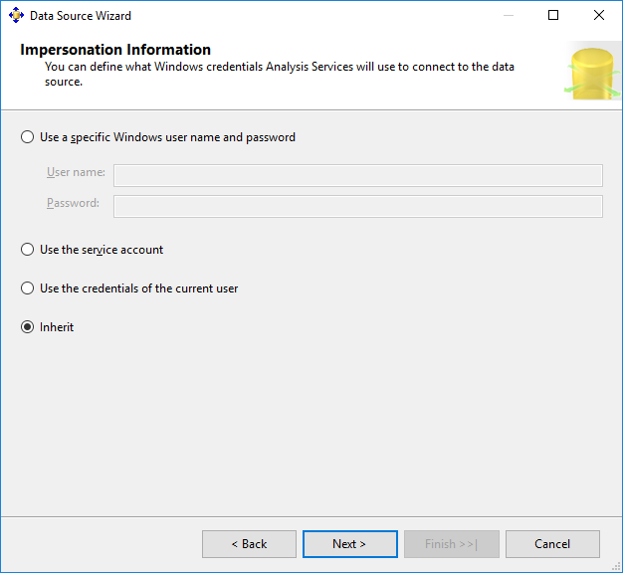

**Click on Next.**

1. **Click on Finish.**

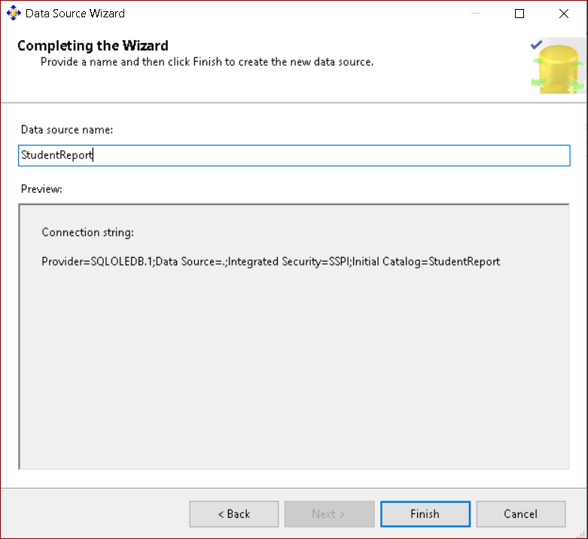

**Name Data Source as “StudentReport”.**

**Practical No 3**

**Aim: Create Data Source View using SSAS (SQL Server Analysis Services.)**

**Solution:**

1. **Right click on Data Source View -> New Data Source View**

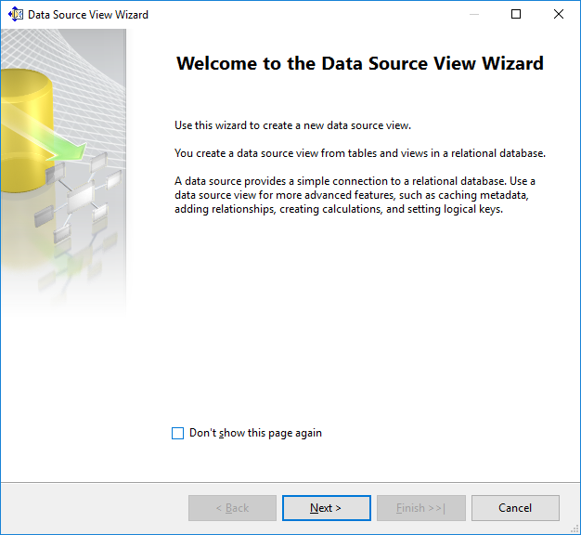

**Click on Next.**

1. **Click on Next.**

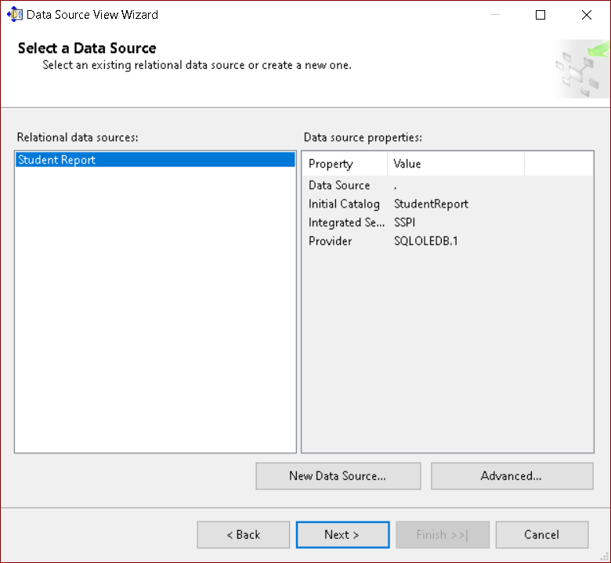

1. **Select Tables and Views.**

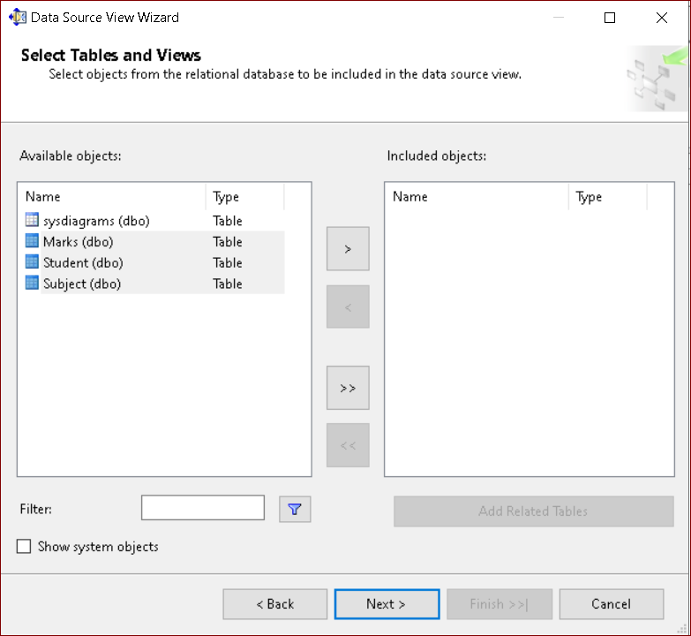

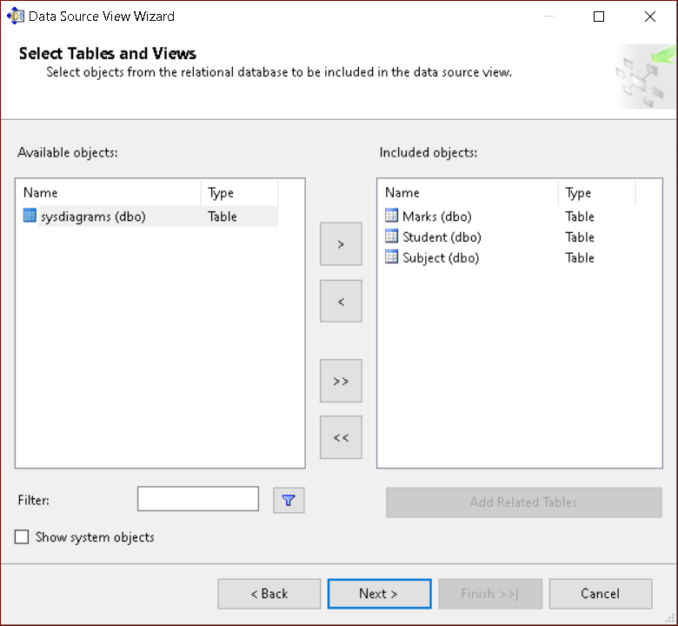

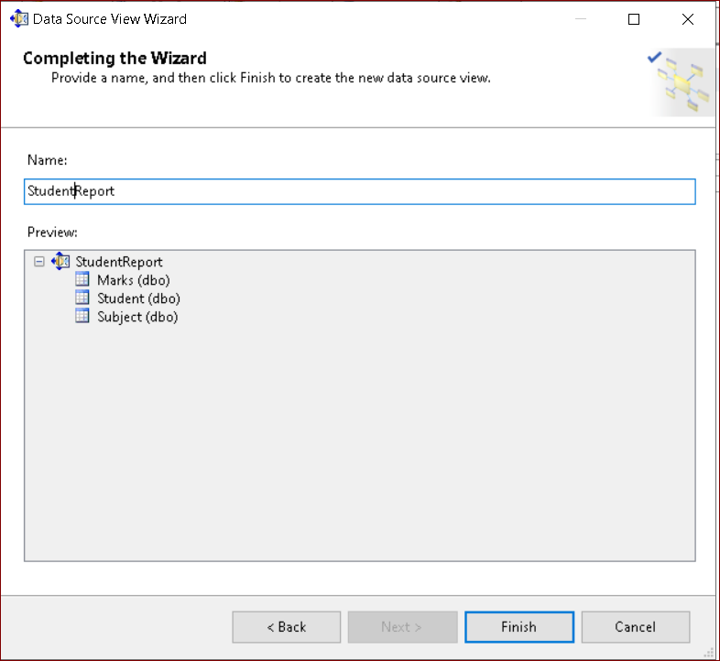

**Name as “Student Report”. Click on Finish.**

1. **Finally, we will get the Data Source View like :**

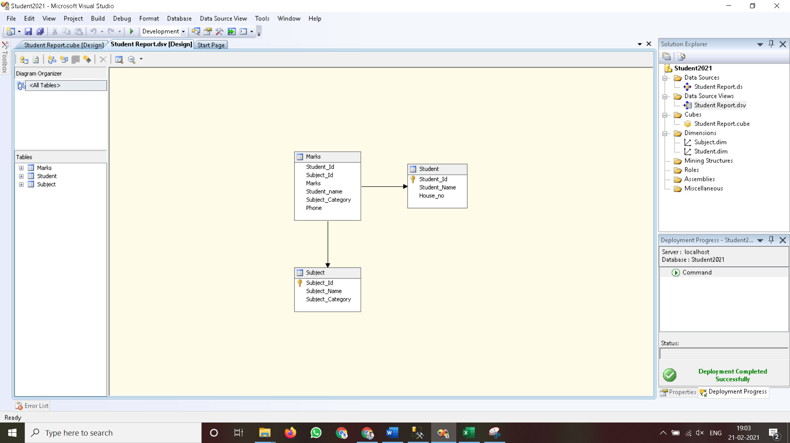

**Practical No 4**

**Aim: Create cube using SSAS (SQL Server Analysis Services.) and process the cube.**

**Solution:**

1. **Right click on Cubes -> New Cube.**

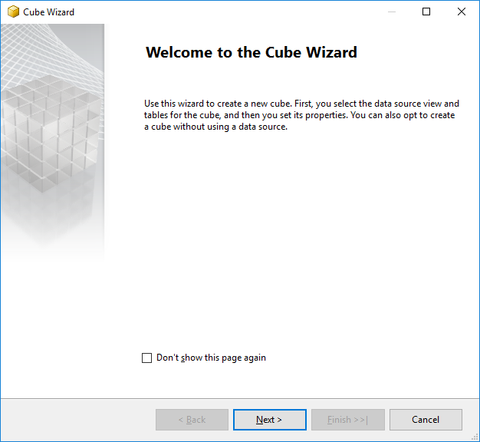

**Click on Next.**

1. **Select First option “Use existing tables”. Click on Next.**

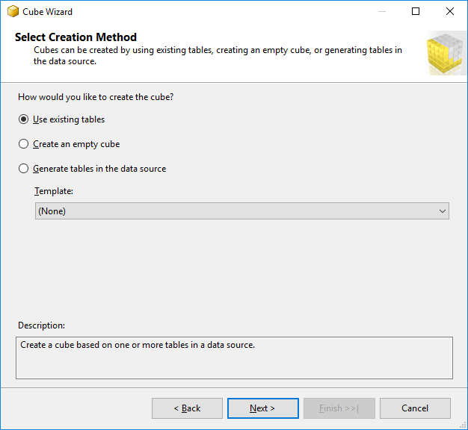

1. **Select Data Source View as “Student Report” and Select all the tables.**

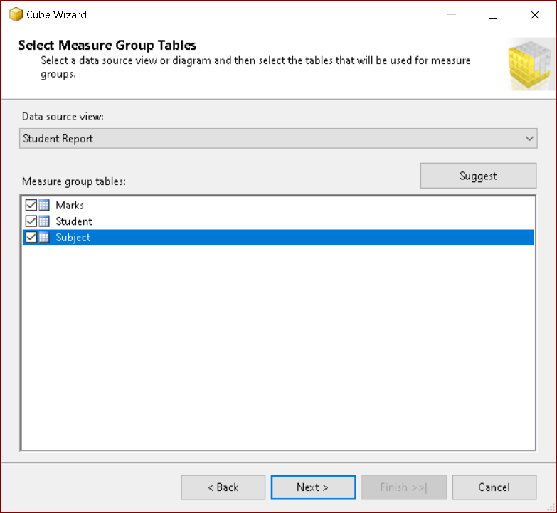

**Click on Next.**

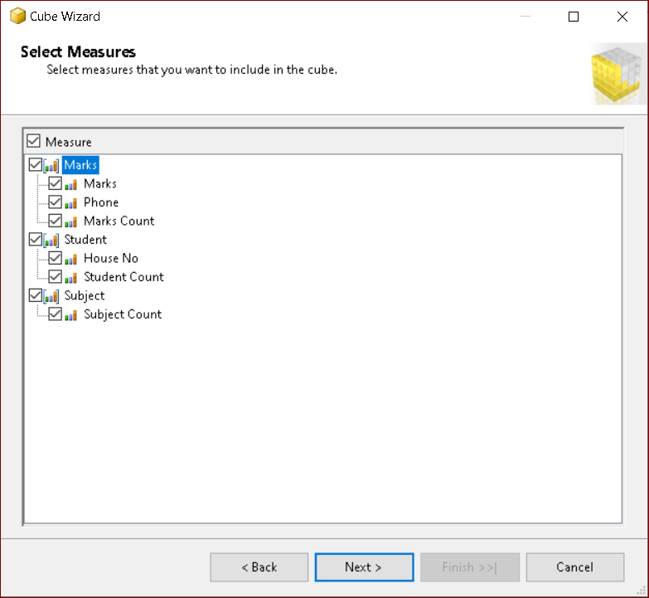

**Click on Next.**

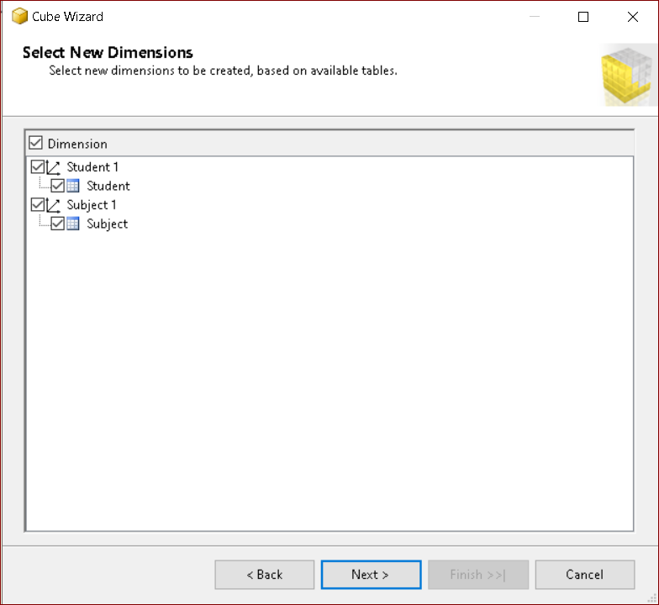

**Click on Next.**

1. **Name Cube as “Student Report”.**

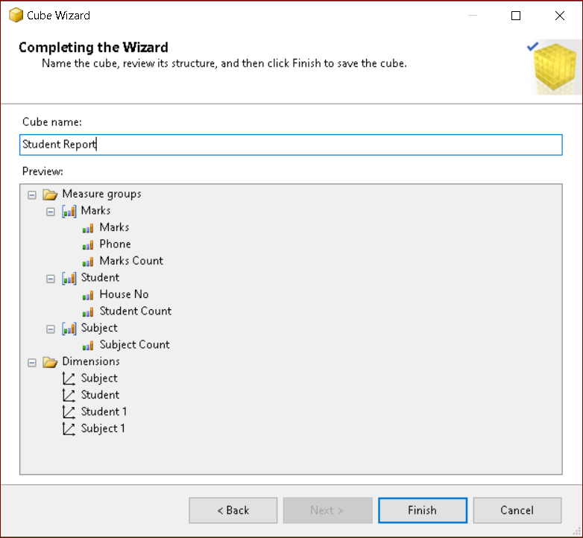

**Click on Finish.**

1. **Finally, we will get the Cube View as well Dimensions View like :**



1. **Finally, Process cube by Right click on “Student Report” -> Process.**

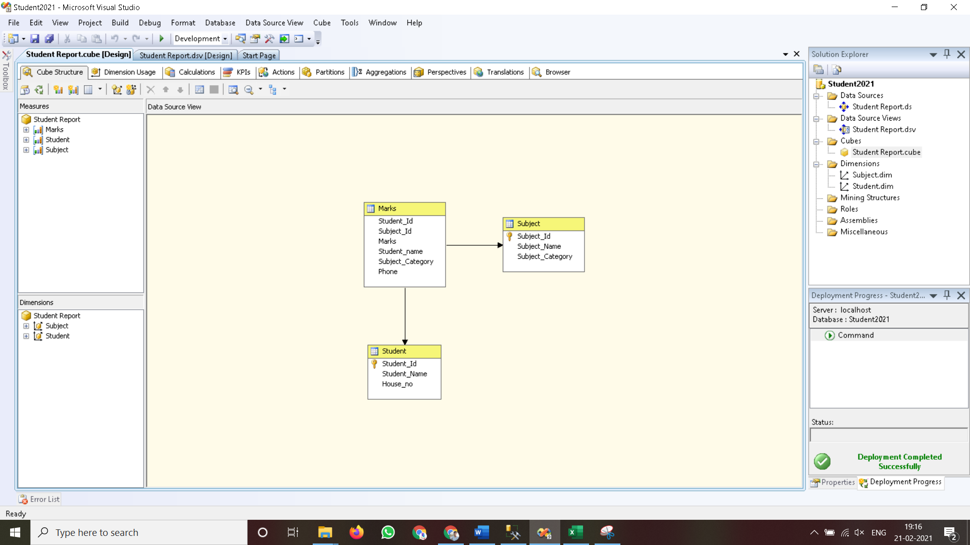

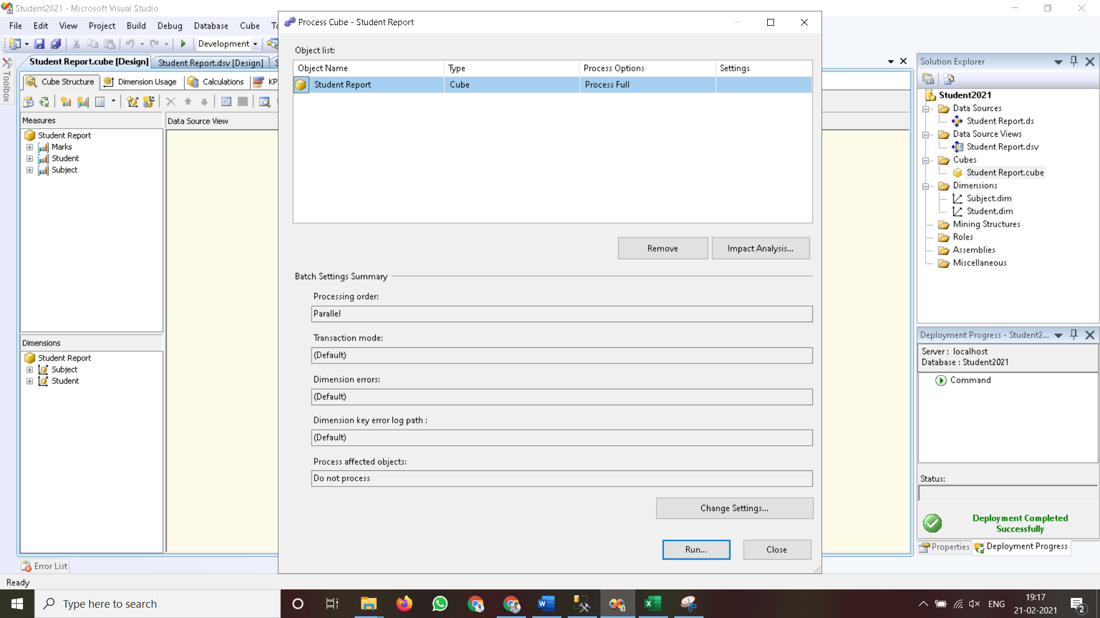

1. **Click on Run.**

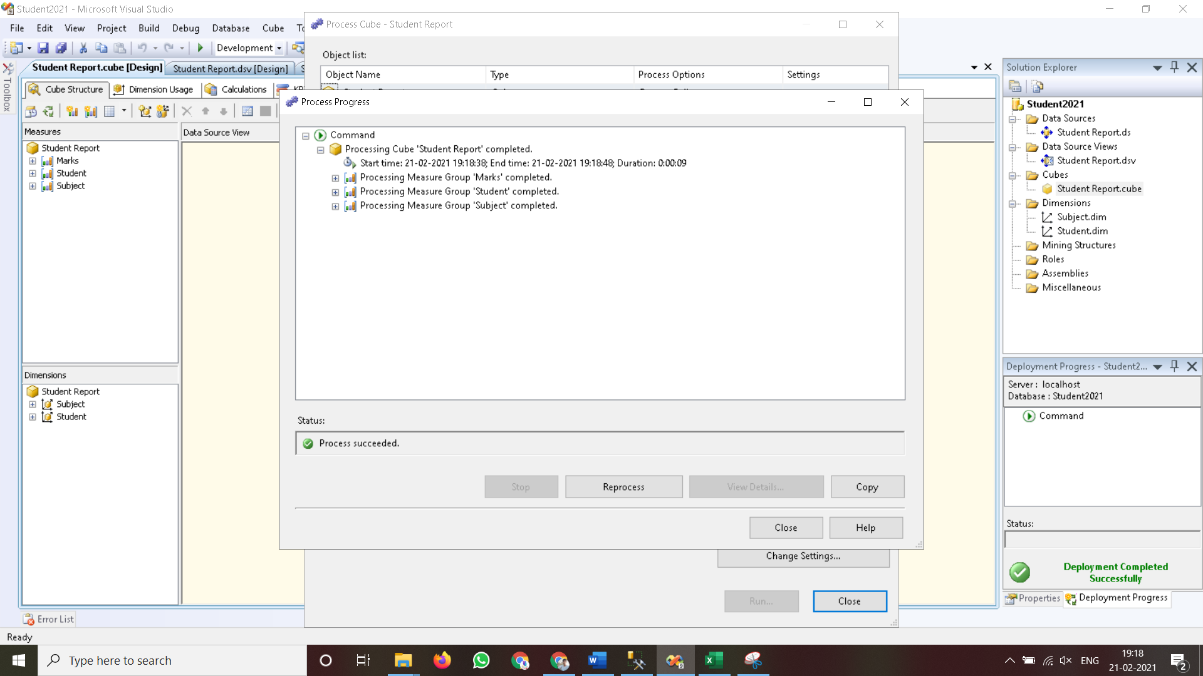

**Practical No 5**

**Aim: View cube data in multidimensional Format.**

**Solution:**

1. **Double Click on “Student Report”. Go to the “Browser” Tab.**

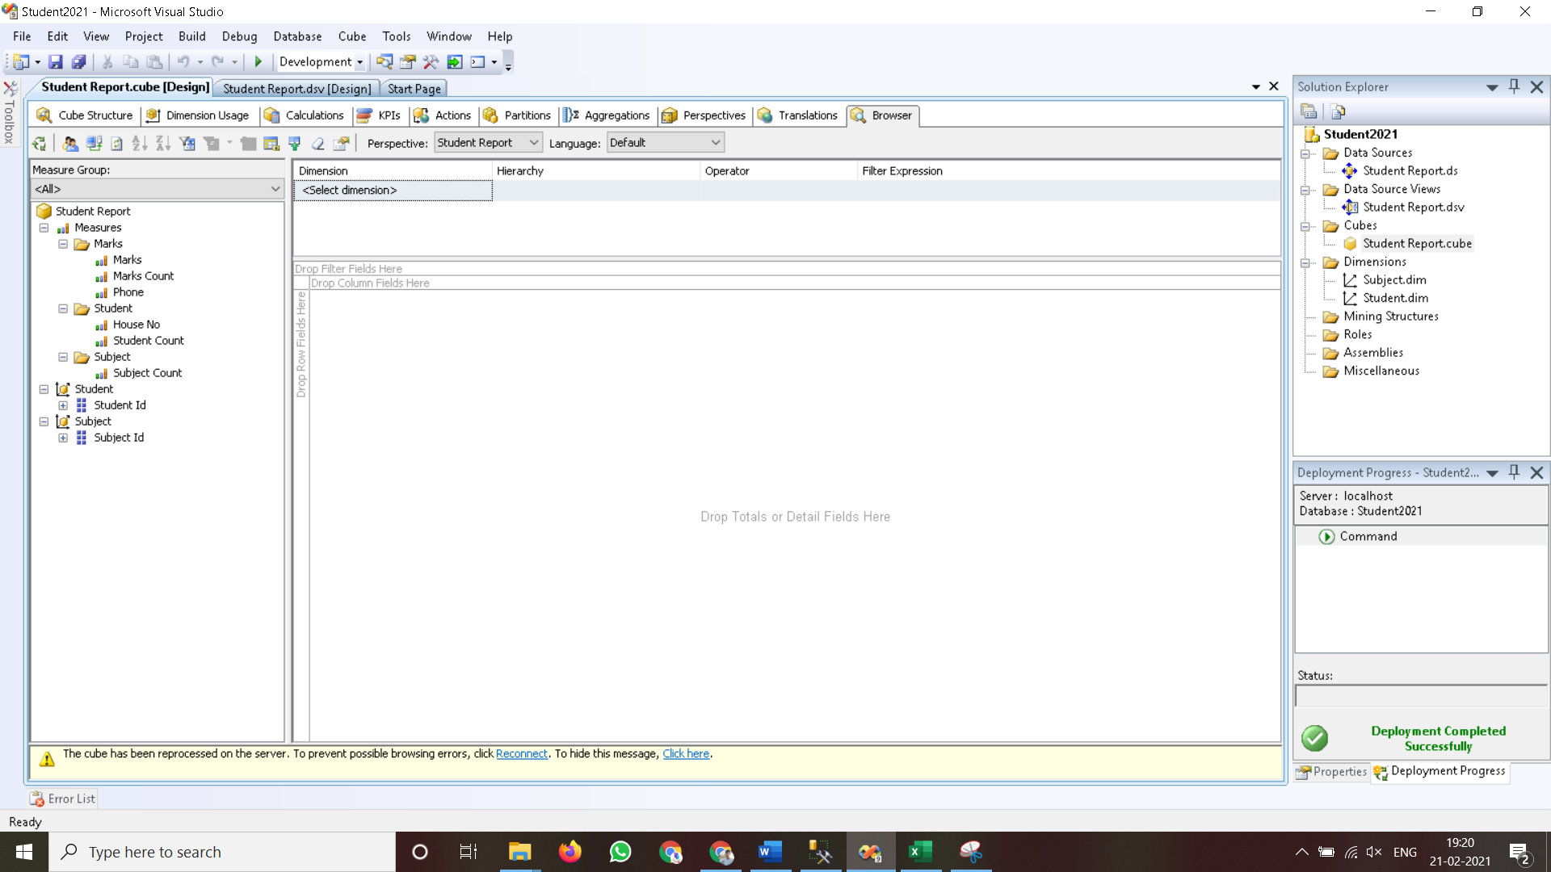

1. **Go to the “Student Dimension”. Right Click on ‘Student_Id’ -> Add to Row Area.**

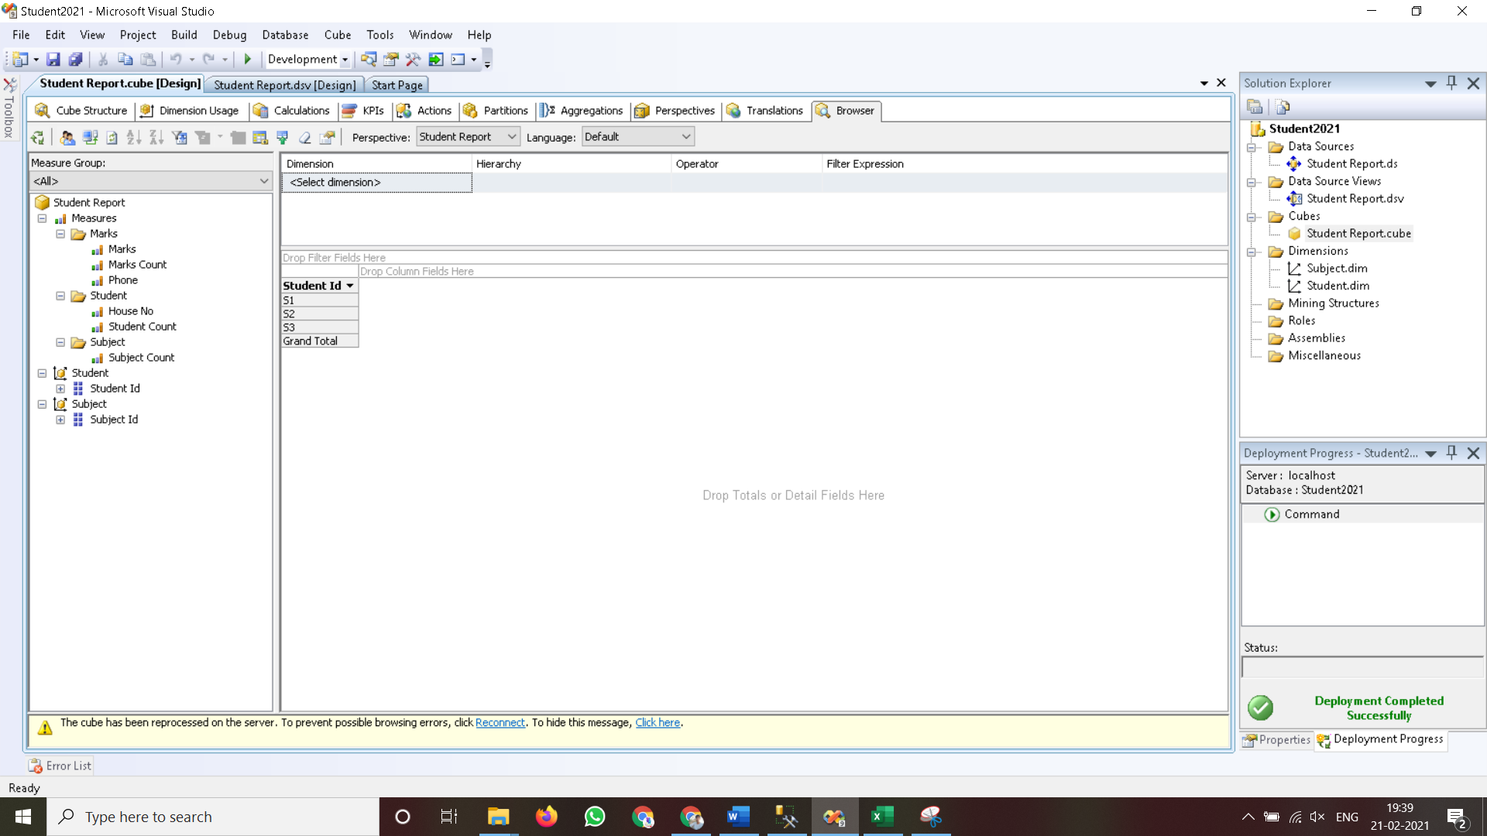

1. **Go to the “Subject Dimension”. Right Click on ‘Subject_Id’ -> Add to Column Area.**

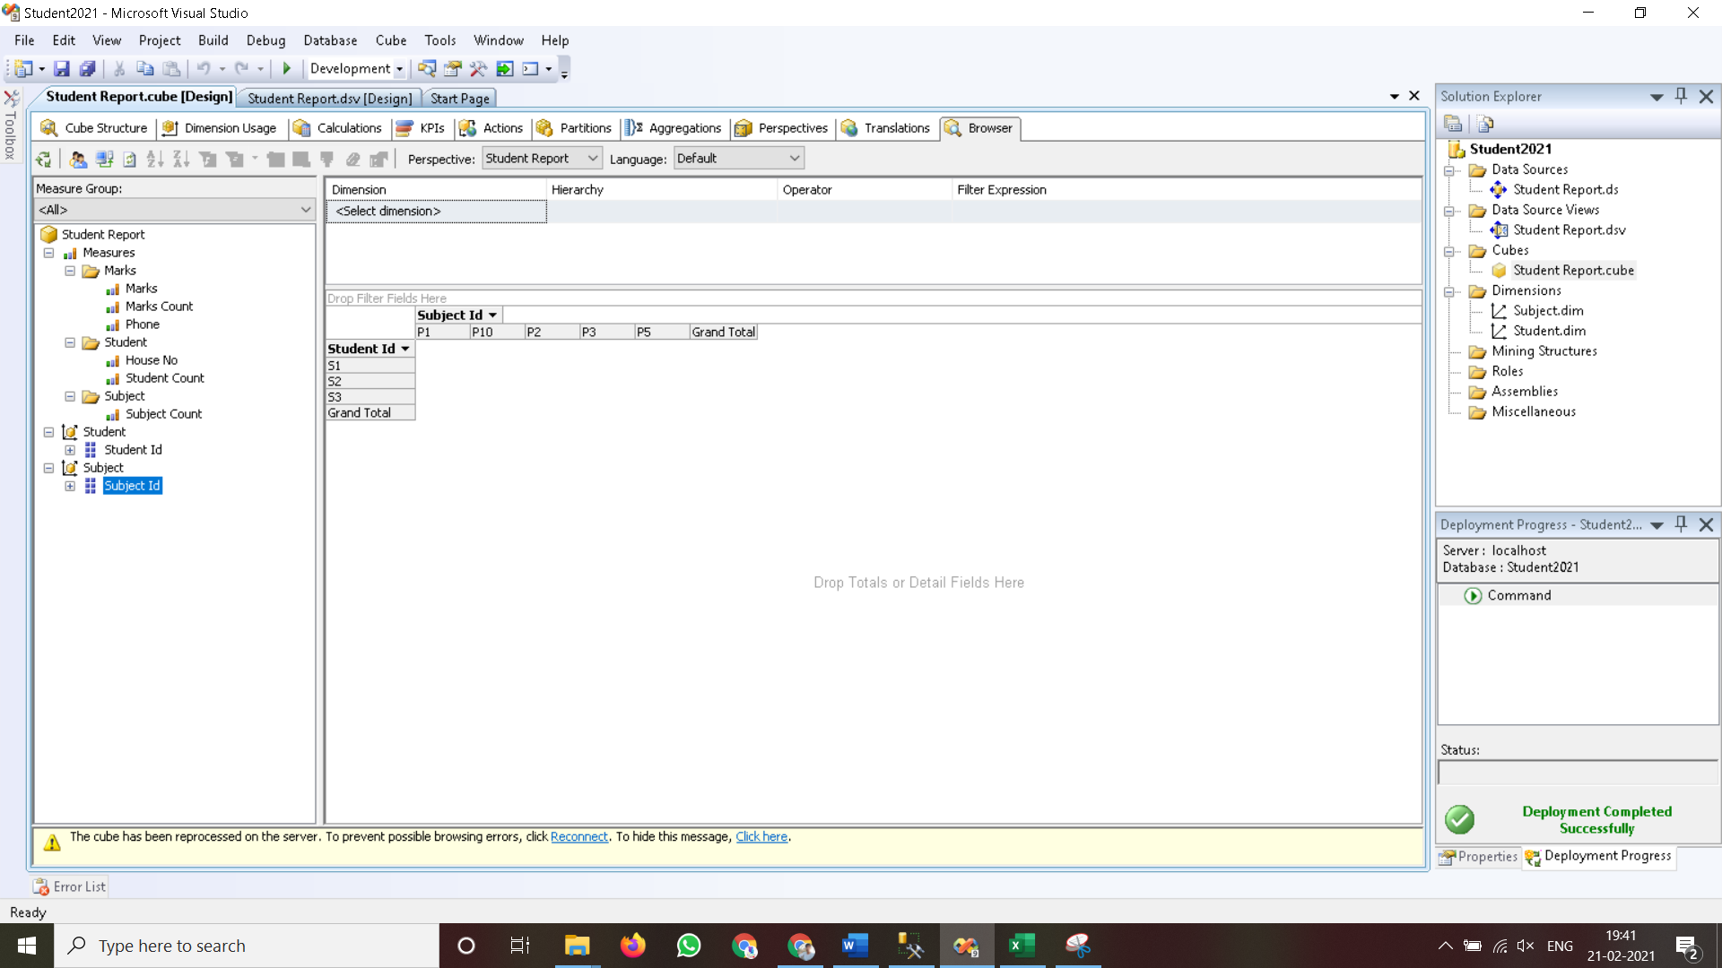

1. **Go to ‘Measures’. Select ‘Marks’ -> Right Click on “Marks” -> Add to Data area.**

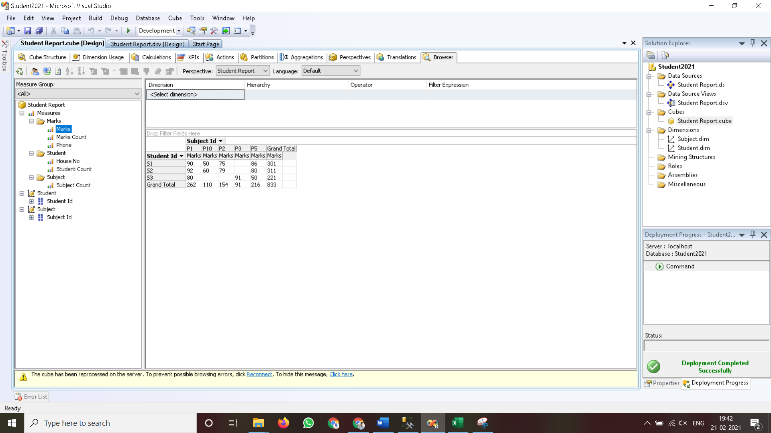

**Practical No 6**

**Aim : Working with measures in the cube.**

**Solution :**

1. **Double click on ‘Student Report’. Go to cube structure.**

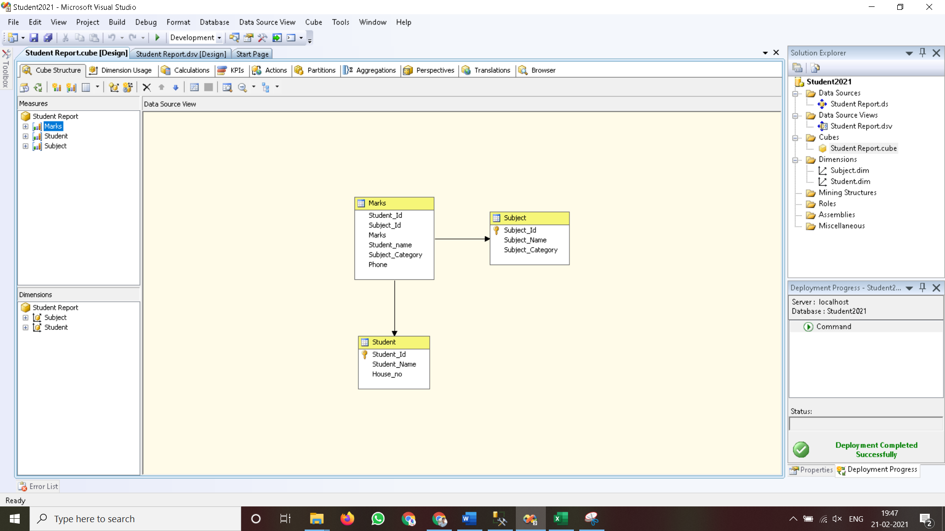

1. **Right click on ‘Marks’ -> New Measure.**

**Select Usage = “Sum” , Source table = “Marks” and Source Column = “Marks”.**

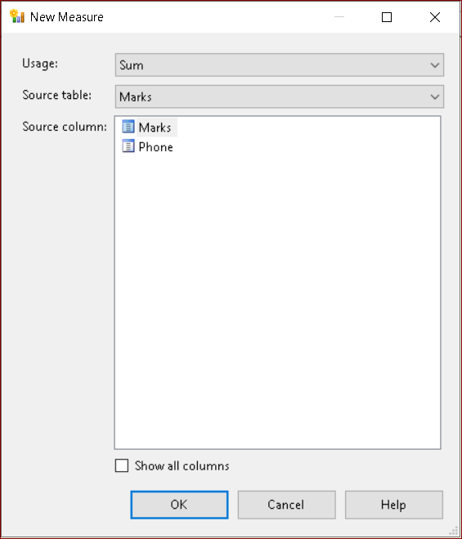

**Click on OK.**

1. **Rename Measure as “Total Marks”.**

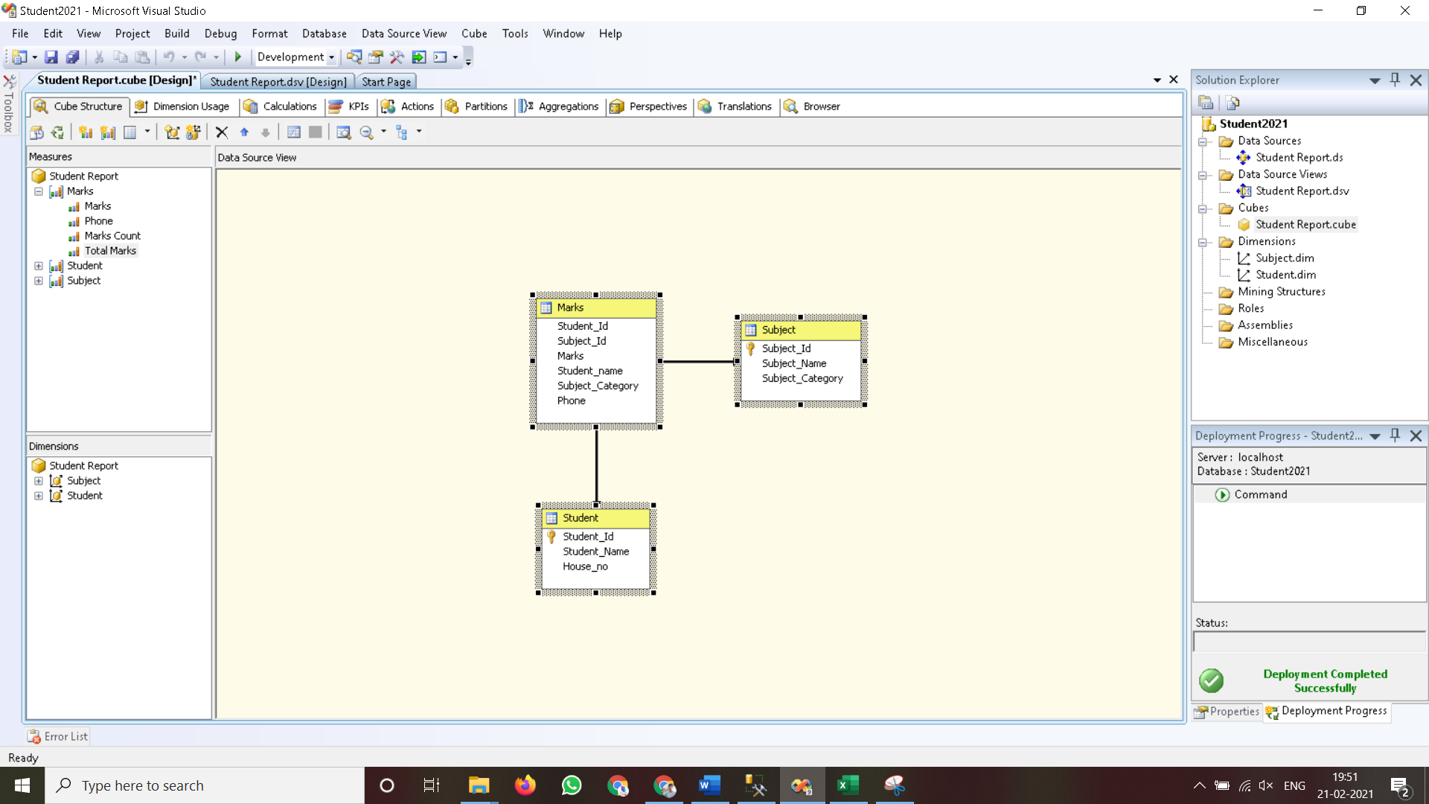

1. **Process Cube and Go to Browser and Reconnect it. Right Click on “Total Marks” -> Add to Data Area.**

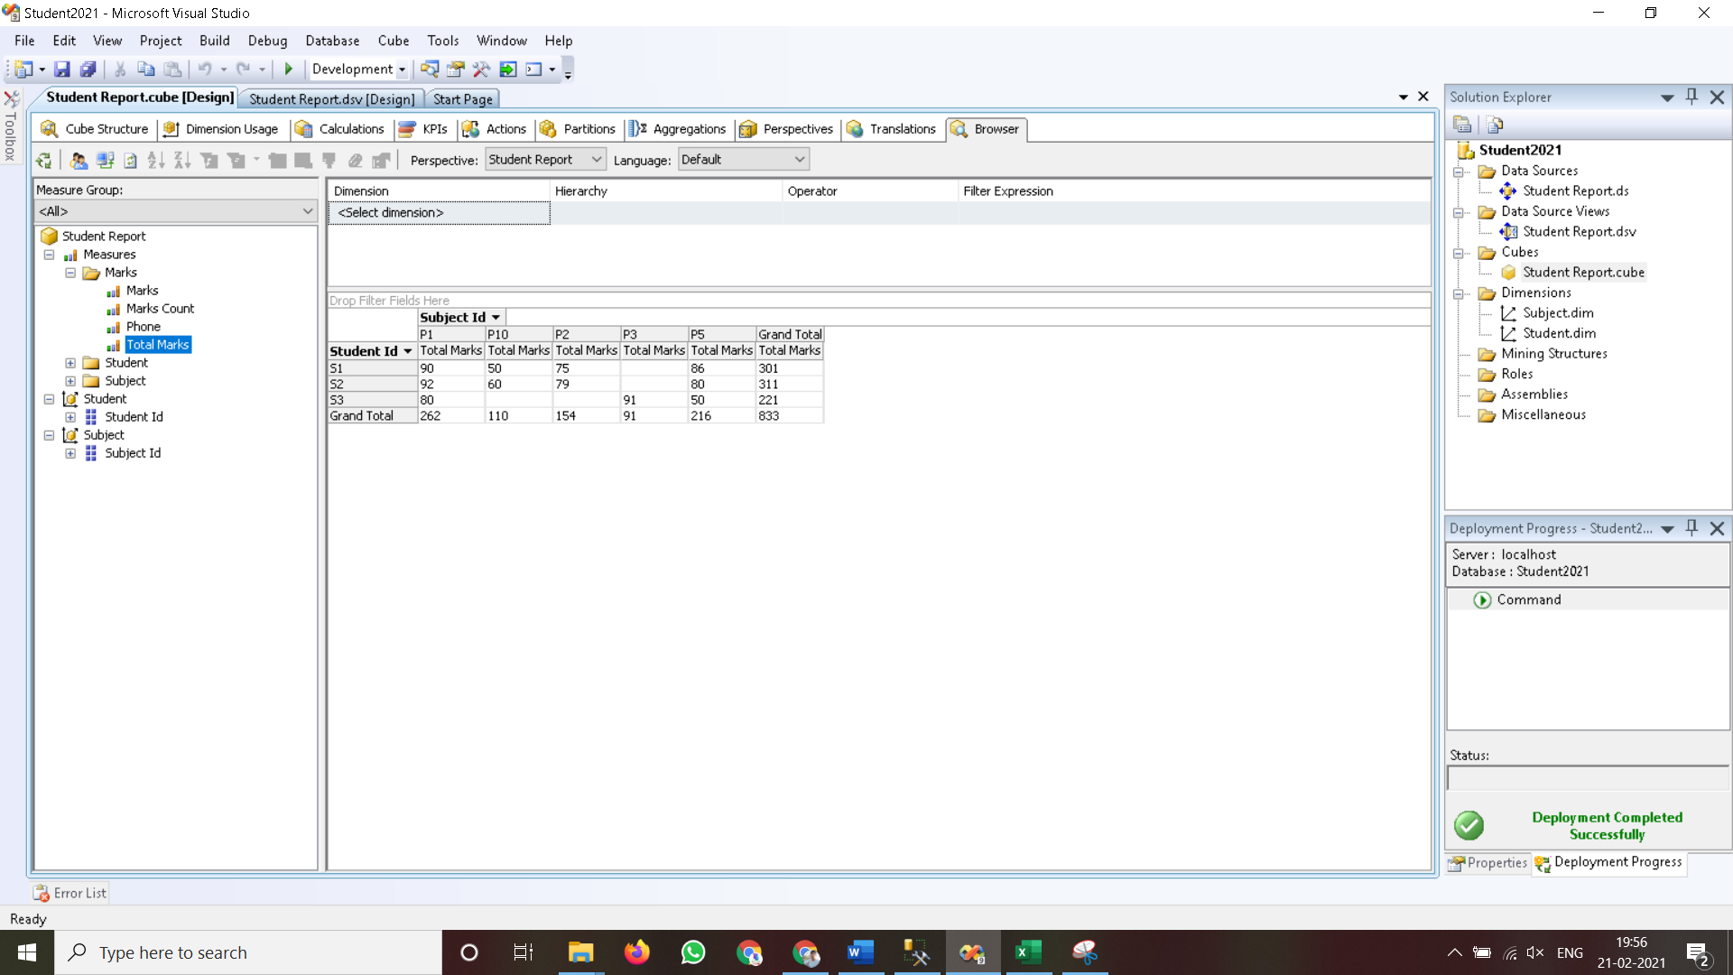

**Practical No 7**

**Aim: Creating an Excel Pivot Table and Pivot Chart by using the OLAP cube data.**

**Solution:**

1. **Open MS-Excel. Click on Data Menu.**
2. **Go to Get Data 🡪 From Database 🡪 From SQL Server Database.**

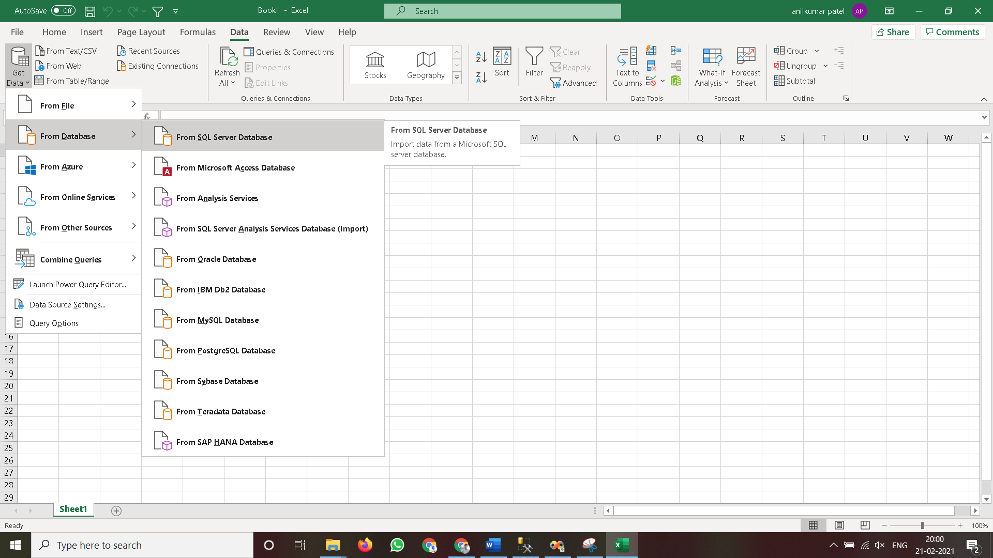

* 1. **From SQL Server -> Type Server name as “.”**

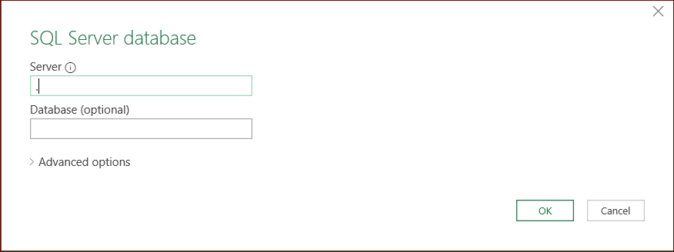

**Click on OK.**

**Choose SQL Database -> “StudentReport”.**

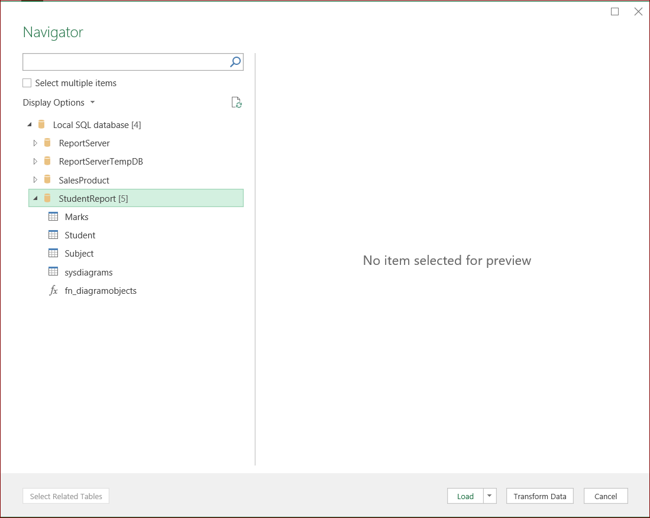

**Click on Load.**

1. **Go to Get Data 🡪 From Database 🡪 From SQL Server Database.**

**Type Server name as “.” & Use Windows Authentication.**

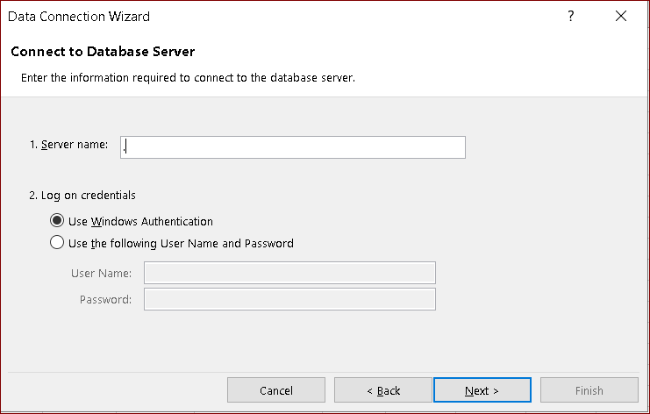

**Click on Next.**

**Choose Analysis Database as “Student2021”. Click on Next.**

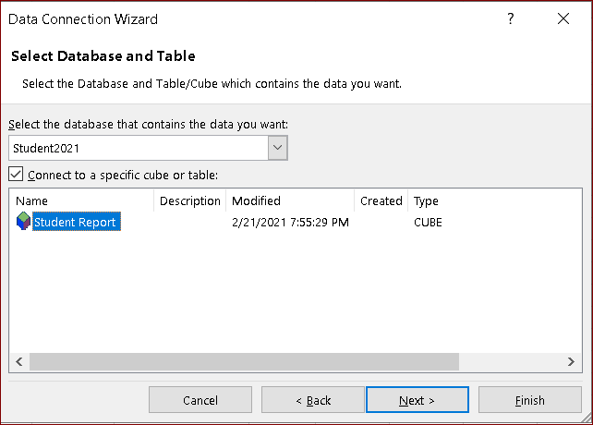

**Click on Finish.**

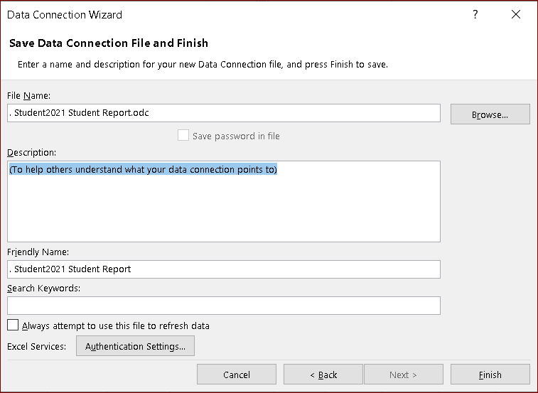

**Click on Finish.**

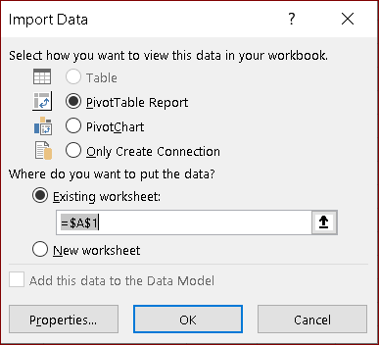

**Click on OK.**

1. **Select PivotTable and Which was created after dragging fields into PivotTable Fields.**

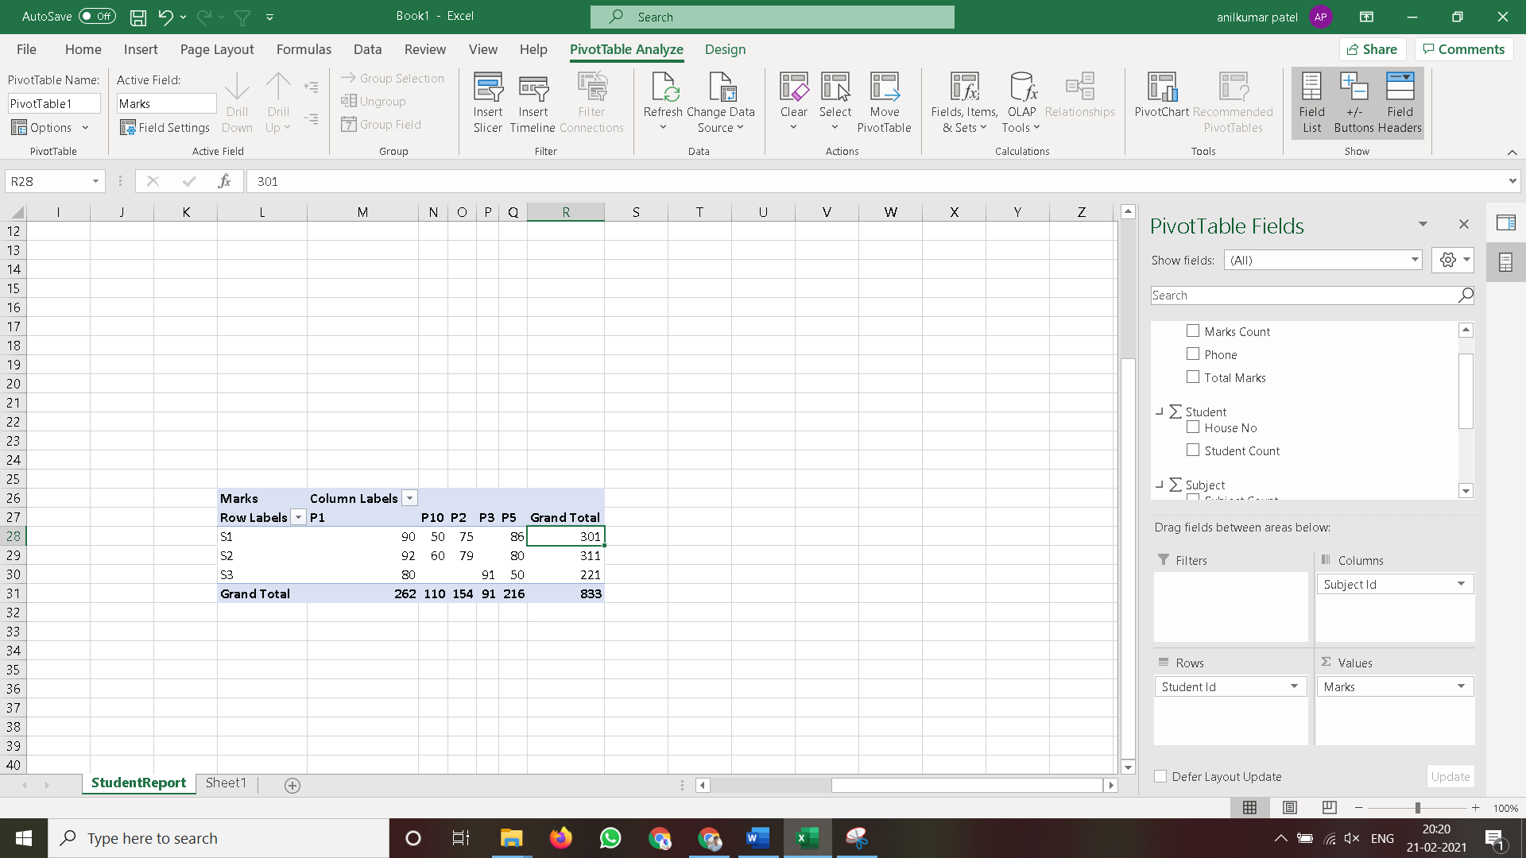

1. **Select Result Area. Go to Insert Menu. Select Pie Chart option.** 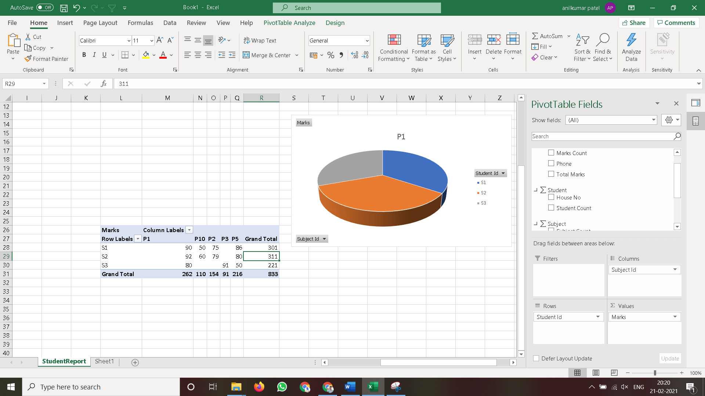
2. **Select Result Area. Go to Insert Menu. Select Column option.**

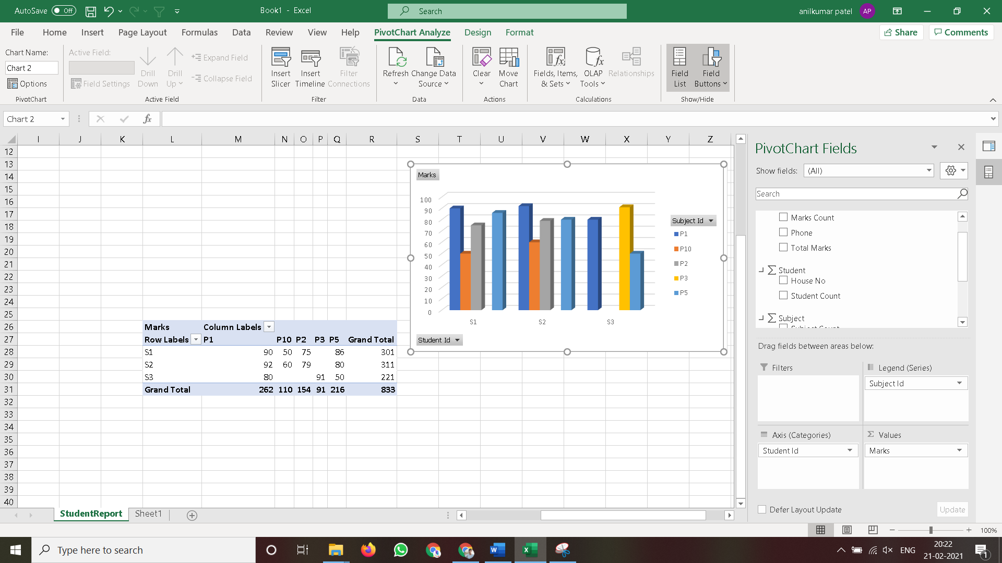

**Practical No 8**

**Aim: Firing Queries on Tables.**

**Solution:**

**Open Application -> Microsoft SQL Server 2008 R2 -> SQL Server Management Studio**

1. **Select Connect Tab -> Database Engine -> Select Server Name(local)**
2. **Expand ‘Database’ -> Expand ‘StudentReport’ -> Expand Tables.**
3. **Fire following queries:**

**3.1.** SELECT [Subject_Id],[Subject_Name],[Subject_Category]

FROM [StudentReport].[dbo].[Subject]

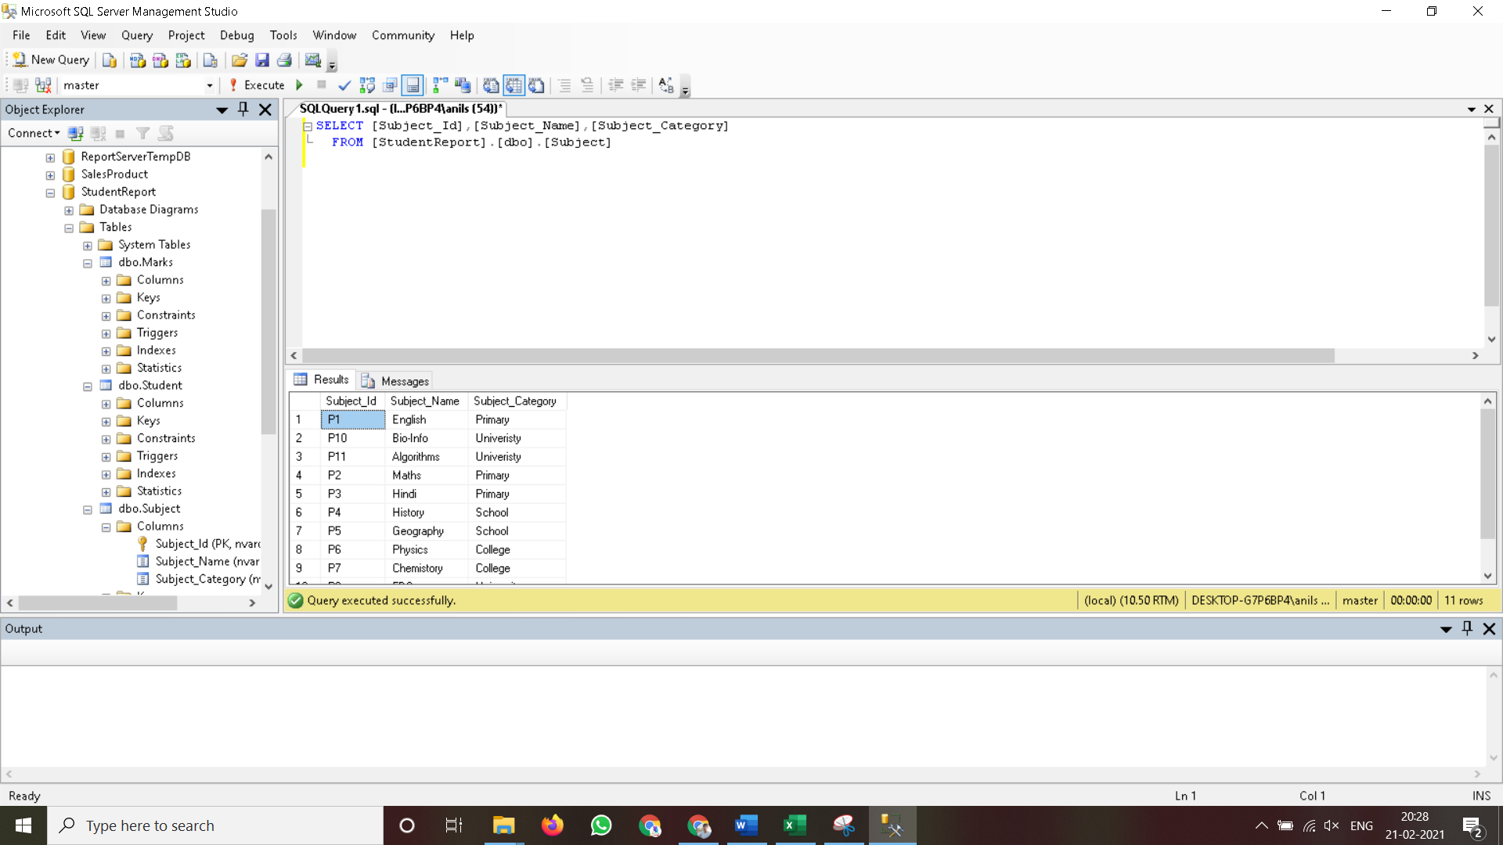

**3.2.** SELECT [Student_Id],[Student_Name]

FROM [StudentReport].[dbo].[Student]

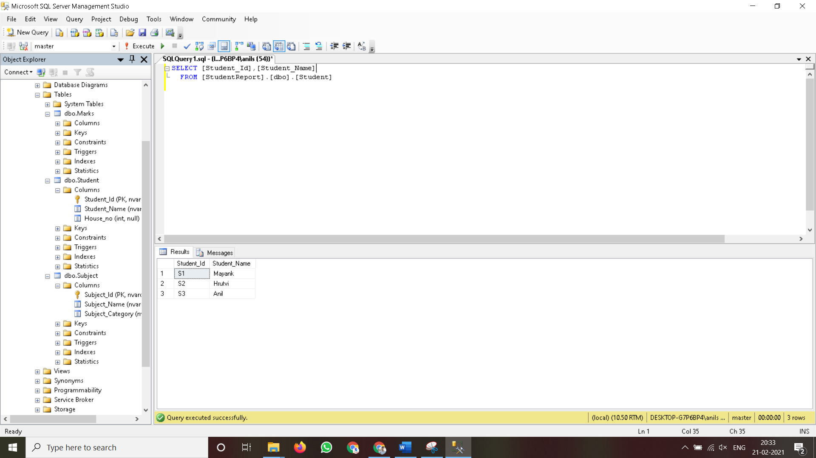

**3.3.** SELECT [Student_Id],[Student_Name],[Subject_Id], [Marks], [Subject_Category] FROM [StudentReport].[dbo].[Marks]

